CMPSC 462 – Assignment-1 (30 points)
Lists and Dictionaries

Due date: 8/30/2022

Note: attach screenshots of your program and results under each programming exercises. Please make sure that the screenshot is readable. Don’t attach a very small screenshot image.

Exercise:(1-5) - 6 points each
Exercise-1:
Write a function called is_sorted (without using inbuilt sort function) that takes a list as a parameter and returns True if the list is sorted in ascending order and False otherwise. You can assume (as a precondition) that the elements of the list can be compared with the relational operators <, >, etc.
For example, is_sorted([1,2,2]) should return True and is_sorted(['b','a']) should return False.
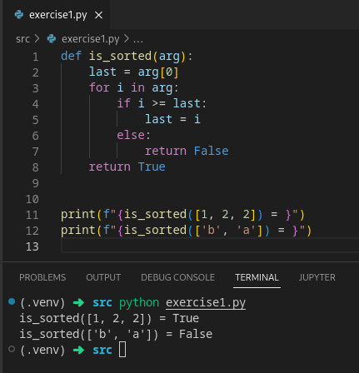

Exercise-2:
What command you would use to do the following for this dictionary:
dict1 = {'a': 10, 'b': 20, 'c': 30, ‘d’:20}
    - Update an entry in dict1
    - Show how to remove the duplicate values from dict1
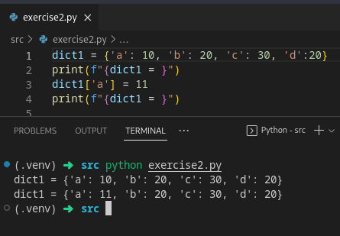

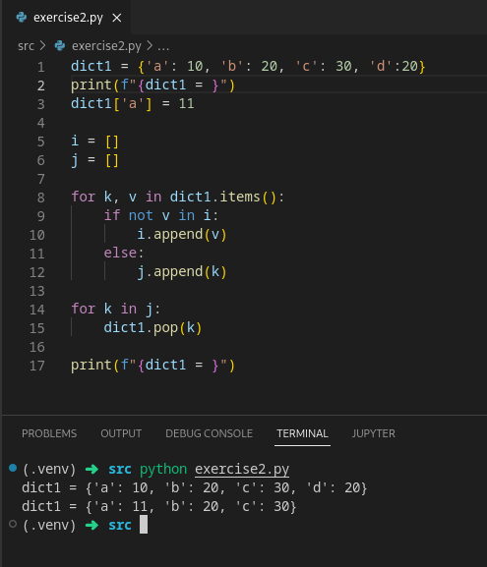

Exercise-3:
Write a function called remove keys(mydict, keylist) that accepts two parameters: a dictionary called mydict and a list called keylist. remove keys(mydict, keylist) should remove all the keys contained in keylist from mydict and return the dictionary:

d = { "key1" : "value1", "key2" : "value2", "key3" : "value3", "key4" : "value4" }
keys = ["key1", "key3", "key5"]

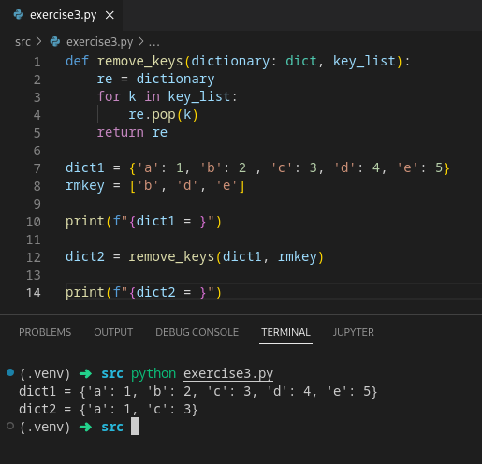

Exercise-4:
Write a function called word frequencies(mylist) that accepts a strings of words and returns a dictionary where the keys are the words from the string of words and the values are the number of times that word appears in mylist:

S = “Fred fed Ted bread, and Ted fed Fred bread”
word_freq = { ’Fred’:2, ’fed’:2, ’Ted’:2, ’bread’:2, ’and’:1}

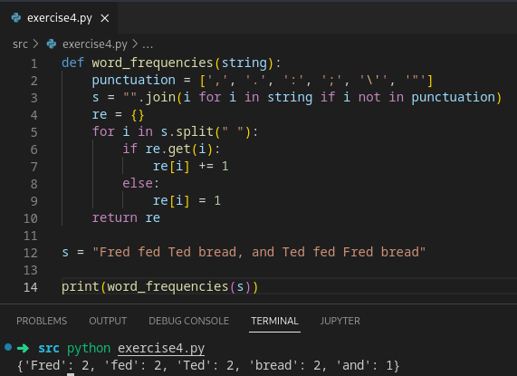

Exercise-5:
Write a Python program to combine two dictionaries, adding values for common keys.
d1 = {'x': 100, 'y': 200, 'm':100}
d2 = {'x': 200, 'n': 100, 'y':200}
